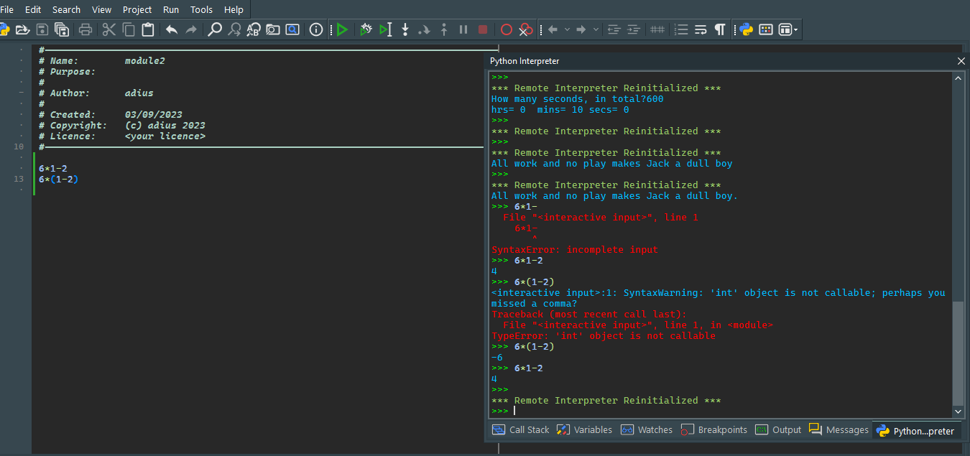Exercice 2

Exercice 3

When I put the comment nothing change the outcome is the same like the comment doesn’t change anything

Exercic 4

Exercice 6

>>> **5**%**2**

1

>>> **9**%**5**

4

>>> **15**%**12**

3

>>> **6**%**6**

0

>>> **0**%**7**

0

>>> **7**%**0**

Traceback (most recent call last):  
  File "<interactive input>", line 1, in <module>  
ZeroDivisionError: integer modulo by zero

>>>